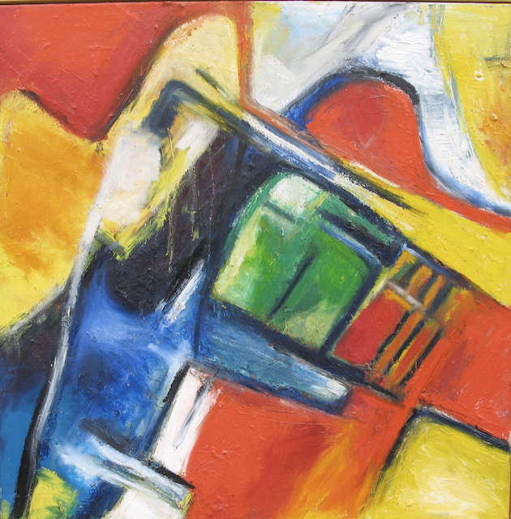
Artist: Beatrice Jud
Name: Wut
Size: 100x 100cm
Material: acrylic on canvas
Price: CHF 5500 now 60% off CHF 2200

